1. Create a tomcat container on 8080 and deploy sample application in tomcat.
2. Create volume and deploy tomcat container on port 8081.
3. Limit the nginx container to 500 MB.
4. Create a sample docker file using below instructions.
a. Base module as amazonlinux:latest.
b. Maintainer you name.
c. Install nginx.
d. COPY one index.html file to image.
e. Expose on port 80.
f. Command to start the nginx container.
5. Push image to Docker hub.
6. push image to AWS ECR.

Task 1 — Create Tomcat Container on Port 8080

Objective
Create a Tomcat container, map the EC2 host's port 8080 to Tomcat's container port 8080, and deploy a sample web application.

Architecture
Browser
|
| http://EC2-PUBLIC-IP:8080
↓
EC2 Ubuntu
|
| Port 8080
↓
Tomcat Container
|
| Container Port 8080
↓
Sample Application

Step 1 — Check Docker
Run:
docker --version
Then:
docker ps
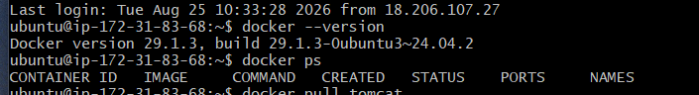

Step 2 — Pull Tomcat image
Run:
docker pull tomcat
Verify:
docker images
You should see something similar to:
REPOSITORY TAG IMAGE ID CREATED SIZE
tomcat latest xxxxxxxxxxxx ... ...

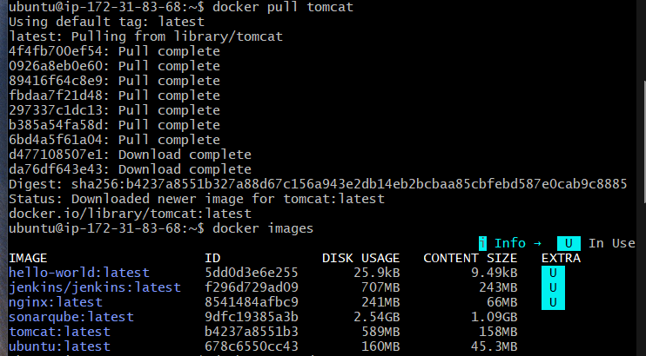

Step 3 — Create the Tomcat container
Run:
docker run -d --name tomcat8080 -p 8080:8080 tomcat
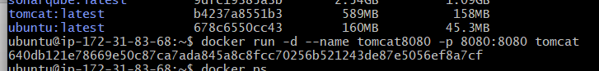
Here:
docker run
creates and starts a container.
-d
runs the container in detached/background mode.
--name tomcat8080
gives the container the name tomcat8080.
-p 8080:8080
maps:
EC2 host port 8080
↓
Container port 8080

Step 4 — Check the container
Run:
docker ps
we should see:
CONTAINER ID IMAGE PORTS
xxxxxxxxxxxx tomcat 0.0.0.0:8080->8080/tcp
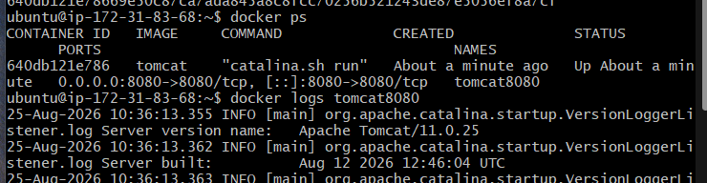

Step 5 — Check Tomcat logs
Run:
docker logs tomcat8080
Look for a message indicating that Tomcat has started.
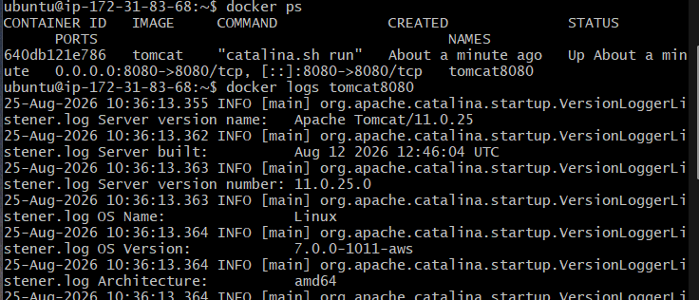
You can also check from the EC2 server:
curl http://localhost:8080

Step 6 — Create a sample application
We'll create a very simple HTML application.
Create a directory:
mkdir sample-app
cd sample-app
Create index.html:
nano index.html
Add:
<!DOCTYPE html>
<html>
<head>
<title>Docker Tomcat Application</title>
</head>
<body>
<h1>Hello from Tomcat Docker Container!</h1>
<p>This application is deployed inside a Tomcat container.</p>
</body>
</html>
Save:
Ctrl + O → Enter → Ctrl + X
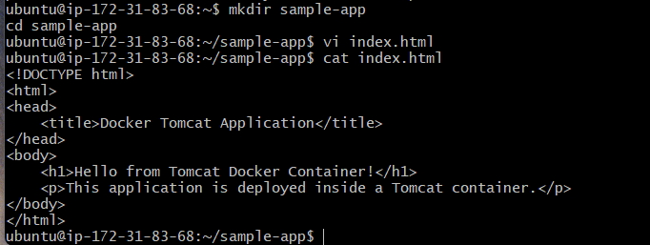

Step 7 — Deploy the application into Tomcat
Tomcat's web applications are deployed under:
/usr/local/tomcat/webapps/
We'll create an application directory called:
sample
Copy the HTML file into the Tomcat container:
docker exec tomcat8080 mkdir -p /usr/local/tomcat/webapps/sample
Then:
docker cp index.html tomcat8080:/usr/local/tomcat/webapps/sample/
Our application is now inside the container:
Tomcat
└── webapps
└── sample
└── index.html

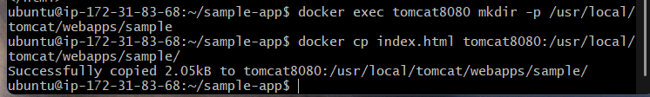

Step 8 — Test the application
From the EC2 machine:
curl http://localhost:8080/sample/
we should see our HTML content.
From our laptop/browser, use:
http://<EC2-PUBLIC-IP>:8080/sample/

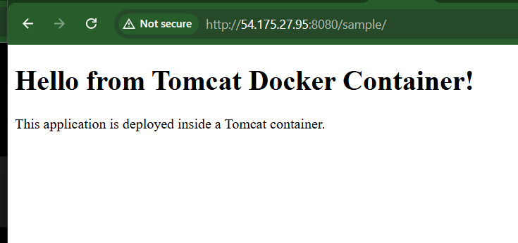

If the browser cannot connect
Check the EC2 Security Group and add:
Type: Custom TCP
Port: 8080
Source: My IP

Task 1 verification
Run:
docker ps
Then:
docker exec tomcat8080 ls /usr/local/tomcat/webapps/sample
Expected:
index.html
And:
curl http://localhost:8080/sample/
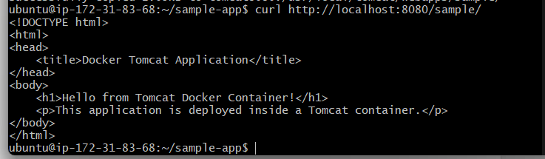

Task 2 — Create Volume and Deploy Tomcat on Port 8081

Objective
Create a Docker volume, attach it to a Tomcat container, and expose Tomcat on port 8081.
The important point is that the Docker volume stores the Tomcat application data outside the container, so the data can survive container deletion.

Architecture
Browser
|
| http://EC2-PUBLIC-IP:8081
↓
EC2
|
| 8081:8080
↓
Tomcat Container
|
| /usr/local/tomcat/webapps
↓
Docker Volume

Step 1 — Create the Docker volume
Run:
docker volume create tomcat-volume
Check it:
docker volume ls
You should see:
DRIVER VOLUME NAME
local tomcat-volume
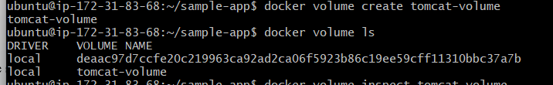

Step 2 — Inspect the volume
Run:
docker volume inspect tomcat-volume
You'll see information such as:
"Name": "tomcat-volume"
"Driver": "local"
"Mountpoint": "/var/lib/docker/volumes/tomcat-volume/_data"
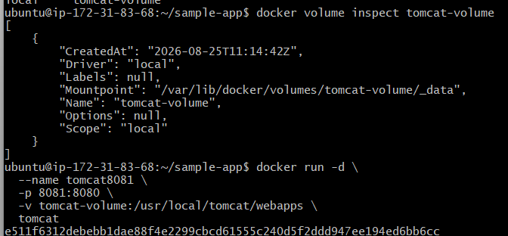
The Mountpoint is where Docker stores the volume's data on the EC2 host.

Step 3 — Create the Tomcat container
Run:
docker run -d \
--name tomcat8081 \
-p 8081:8080 \
-v tomcat-volume:/usr/local/tomcat/webapps \
Tomcat
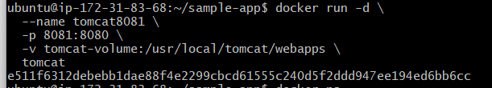

Understand the command
docker run
Creates and starts a container.
-d
Runs the container in the background.
--name tomcat8081
Names the container tomcat8081.
-p 8081:8080
Maps:
EC2 port 8081
↓
Tomcat container port 8080
So you access this Tomcat using:
http://EC2-PUBLIC-IP:8081
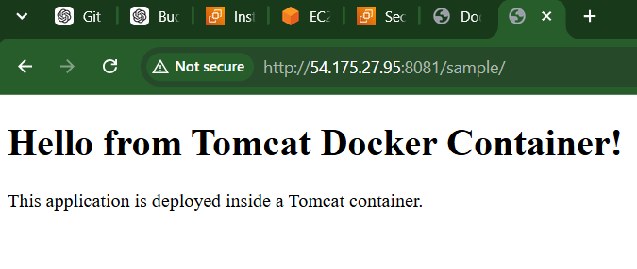
Mounts:
Docker volume
↓
/usr/local/tomcat/webapps
inside the container.

Step 4 — Check the container
Run:
docker ps
You should see something similar to:
CONTAINER ID IMAGE PORTS
xxxxxxxxxxxx tomcat 0.0.0.0:8081->8080/tcp
You now have two Tomcat containers:
tomcat8080 → 8080:8080
tomcat8081 → 8081:8080
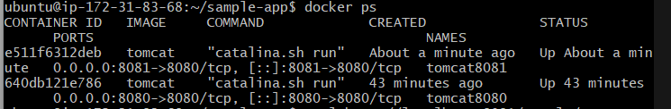

Step 5 — Verify the volume is mounted
Run:
docker inspect tomcat8081
Look for the Mounts section.
You should see something similar to:
"Type": "volume",
"Name": "tomcat-volume",
"Destination": "/usr/local/tomcat/webapps"
This confirms that the volume is attached to Tomcat's webapps directory.
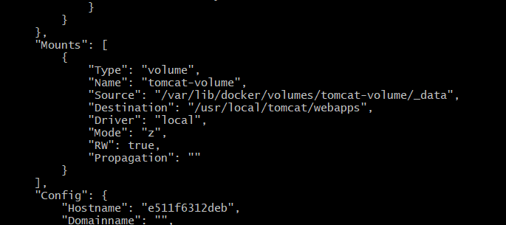

Step 6 — Deploy a sample application
Create another application directory on your EC2 host:
mkdir -p ~/sample-app-8081
cd ~/sample-app-8081
Create the HTML file:
nano index.html
Put:
<!DOCTYPE html>
<html>
<head>
<title>Tomcat Volume Application</title>
</head>
<body>
<h1>Hello from Tomcat on Port 8081!</h1>
<p>This application is stored using a Docker volume.</p>
</body>
</html>
Save with:
Ctrl + O
Enter
Ctrl + X
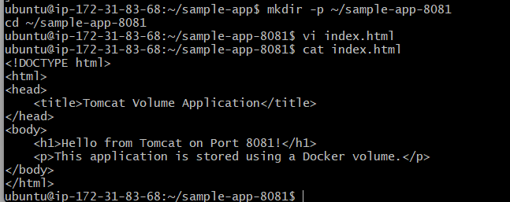

Step 7 — Copy the application into Tomcat
Create the application directory:
docker exec tomcat8081 mkdir -p /usr/local/tomcat/webapps/sample
Copy the file:
docker cp index.html tomcat8081:/usr/local/tomcat/webapps/sample/
Verify:
docker exec tomcat8081 ls /usr/local/tomcat/webapps/sample
Expected:
index.html
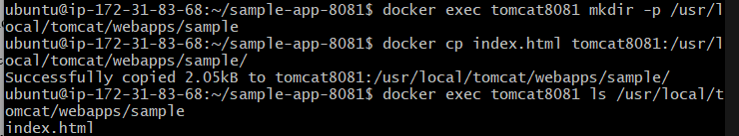

Step 8 — Test the application
From the EC2 instance:
curl http://localhost:8081/sample/
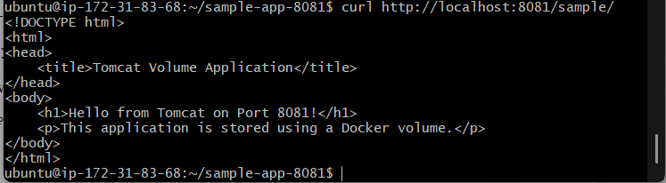
You should get your HTML content.
From your browser:
http://<EC2-PUBLIC-IP>:8081/sample/
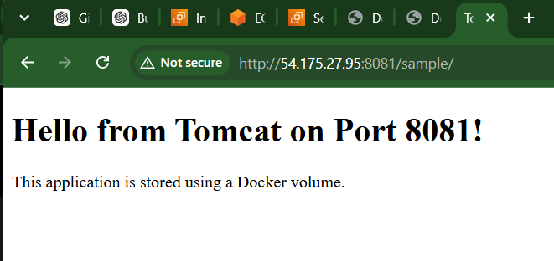

Step 9 — Verify volume persistence
This is the important part of the task.
First, verify the application exists:
docker exec tomcat8081 ls /usr/local/tomcat/webapps/sample
Then remove the container:
docker rm -f tomcat8081
Notice that we're deleting the container, not the volume.
Check:
docker volume ls
You should still see:
tomcat-volume
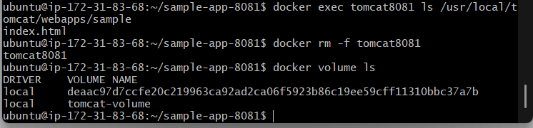

Step 10 — Create another Tomcat container using the same volume
Run:
docker run -d \
--name tomcat8081-new \
-p 8081:8080 \
-v tomcat-volume:/usr/local/tomcat/webapps \
tomcat
Now check:
docker exec tomcat8081-new ls /usr/local/tomcat/webapps/sample
You should still get:
index.html
This proves that the application data remained in the Docker volume even after the original container was deleted.
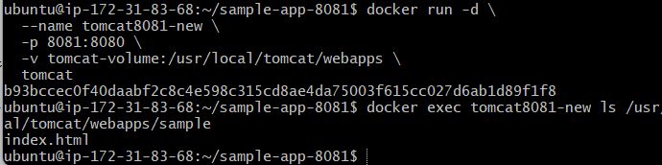

Task 3 — Limit the Nginx Container to 500 MB

Objective
Run an Nginx container with a maximum memory limit of 500 MB.

Step 1 — Check your existing Nginx container
Run:
docker ps -a
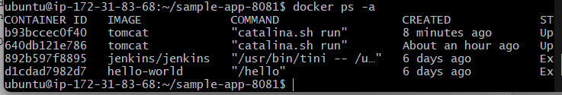

Step 2 — Run Nginx with 500 MB memory limit
If there is no existing Nginx container, run:
docker run -d \
--name nginx500 \
-p 81:80 \
--memory=500m \
nginx
Here:
--memory=500m
means the container can use a maximum of 500 MB RAM.
And:
-p 81:80
means:
EC2 port 81
↓
Nginx container port 80

Step 3 — Verify the memory limit
Run:
docker inspect nginx500 --format='{{.HostConfig.Memory}}'
The result will be in bytes.
For example:
524288000
because:
500 × 1024 × 1024 = 524,288,000 bytes

Step 4 — Easier verification
Run:
docker stats nginx500 --no-stream
You'll see something similar to:
CONTAINER ID NAME CPU % MEM USAGE / LIMIT
xxxxxxxxxxxx nginx500 0.00% 1.5MiB / 500MiB
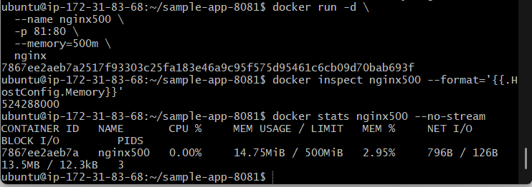
The important part is:
500MiB
as the memory limit.

Step 5 — Test Nginx
Run:
curl http://localhost:81
You should receive the Nginx HTML response.
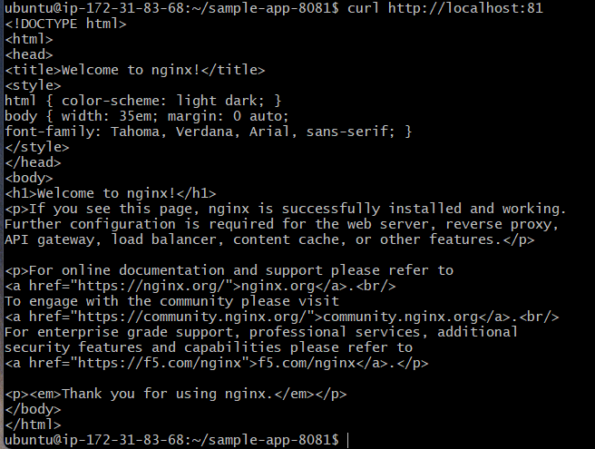
You can also access:
http://<EC2-PUBLIC-IP>:81
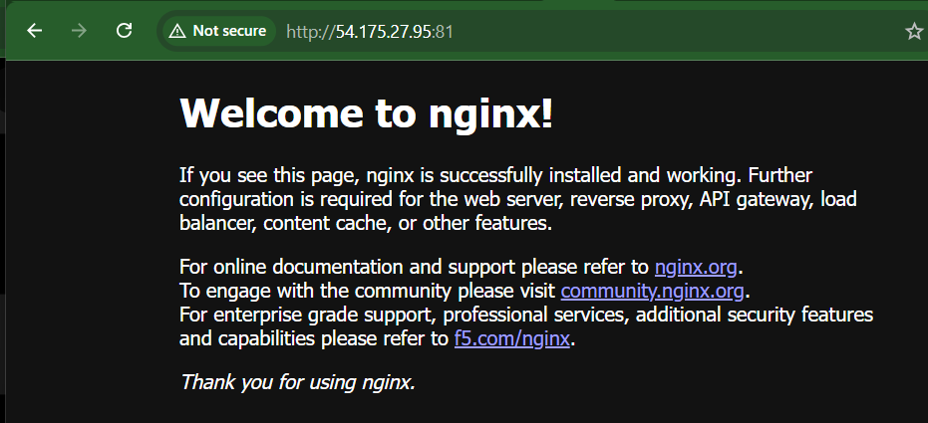

Task 4. Create a sample docker file using below instructions..
a. Base module as amazonlinux:latest.
b. Maintainer you name.
c. Install nginx.
d. COPY one index.html file to image.
e. Expose on port 80.
f. Command to start the nginx container.
We will create an image based on amazonlinux:latest and install Nginx inside it.

Required Dockerfile
amazonlinux:latest
↓
Install Nginx
↓
Copy index.html
↓
Expose port 80
↓
Start Nginx

Step 1 — Create a directory
Go to your home directory:
cd ~
Create a directory:
mkdir dockerfile-task
Enter it:
cd dockerfile-task
Verify:
pwd
You should have something similar to:
/home/ubuntu/dockerfile-task
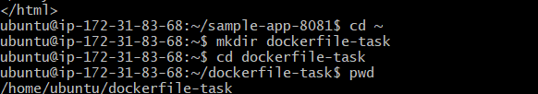

Step 2 — Create index.html
Run:
nano index.html
Add:
<!DOCTYPE html>
<html>
<head>
<title>Amazon Linux Nginx</title>
</head>
<body>
<h1>Hello from Nginx!</h1>
<p>This image was created using a Dockerfile based on Amazon Linux.</p>
</body>
</html>
Save:
Ctrl + O
Enter
Ctrl + X
Verify:
cat index.html
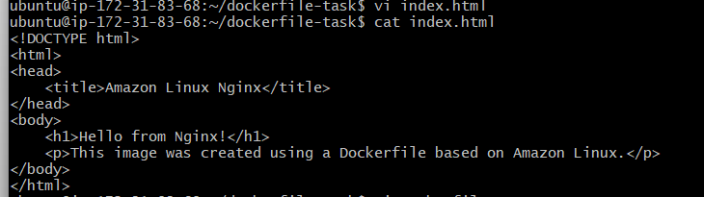

Step 3 — Create the Dockerfile
Run:
nano Dockerfile
Put this in it:
FROM amazonlinux:latest

LABEL maintainer="Nikhil Reddy"

RUN dnf install -y nginx && \
dnf clean all

COPY index.html /usr/share/nginx/html/index.html

EXPOSE 80

CMD ["nginx", "-g", "daemon off;"]

Explanation
FROM amazonlinux:latest
Uses the latest Amazon Linux image as the base image.
LABEL maintainer="Nikhil Reddy"
Adds our name as the image maintainer.
RUN dnf install -y nginx
Installs Nginx inside the image.
COPY index.html /usr/share/nginx/html/index.html
Copies your local index.html into Nginx's default web root.
Local:
index.html
↓
Image:
/usr/share/nginx/html/index.html
EXPOSE 80
Documents that Nginx listens on port 80 inside the container.
CMD ["nginx", "-g", "daemon off;"]
Starts Nginx when the container starts.
daemon off; is important because Docker needs Nginx to remain in the foreground. Otherwise, the container could exit after Nginx starts as a background process.
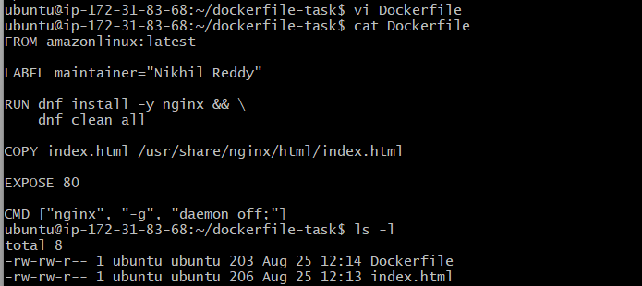

Step 4 — Verify the files
Run:
ls -l
You should see:
Dockerfile
index.html
Then:
cat Dockerfile

Step 5 — Build the Docker image
Run:
docker build -t amazonlinux-nginx:v1 .
Here:
docker build
Builds an image from the Dockerfile.
-t amazonlinux-nginx:v1
assigns the image name and tag.
.
means use the current directory as the build context.
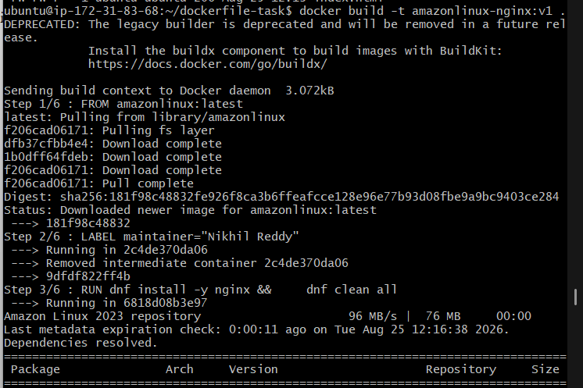

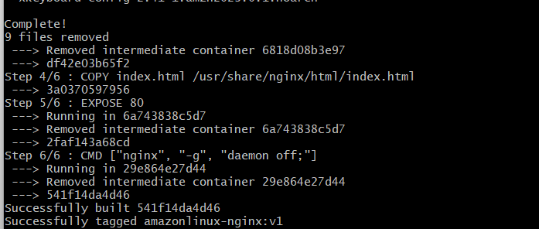

Step 6 — Verify the image
Run:
docker images
You should see:
REPOSITORY TAG IMAGE ID CREATED
amazonlinux-nginx v1 xxxxxxxxxxxx ...

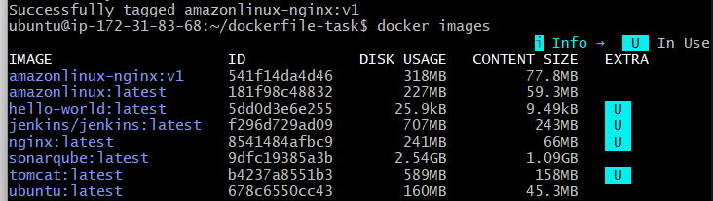

Step 7 — Run your custom image
Run:
docker run -d \
--name amazonlinux-nginx \
-p 8082:80 \
amazonlinux-nginx:v1
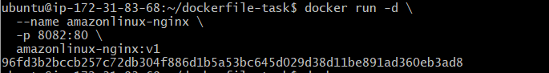
Here:
EC2 port 8082
↓
Container port 80
↓
Nginx
Check:
docker ps
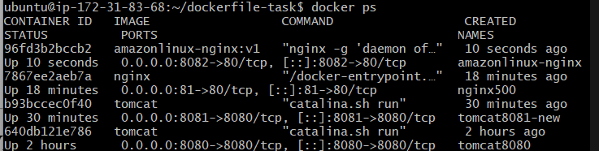

Step 8 — Test the application
From EC2:
curl http://localhost:8082
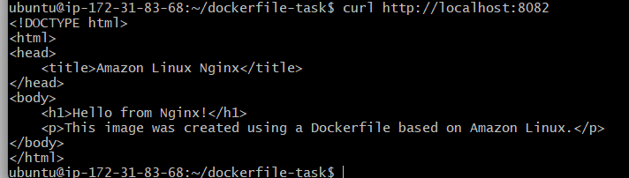
You should receive:
<h1>Hello from Nginx!</h1>
You can also open:
http://<EC2-PUBLIC-IP>:8082
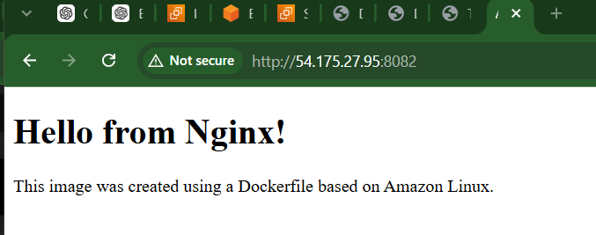

Task 5 — Push Image to Docker Hub
We will push:
amazonlinux-nginx:v1
to your Docker Hub repository.

Step 1 — Create a Docker Hub repository
Go to Docker Hub and log in.
Create a new repository, for example:
amazonlinux-nginx
Keep the repository Public if this is just for your practical.
Your repository will look like:
<dockerhub-username>/amazonlinux-nginx
For example:
nikhilreddy/amazonlinux-nginx
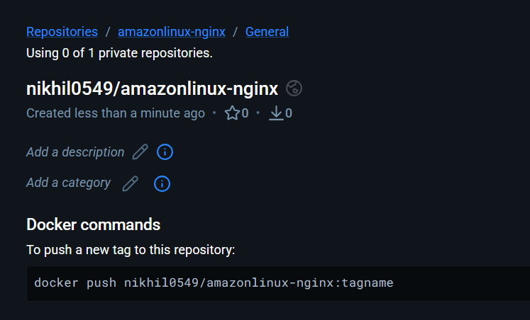

Step 2 — Login to Docker Hub from EC2
Run:
docker login
Docker will ask for:
Username:
Password:
Enter your Docker Hub credentials.
If Docker Hub has 2FA enabled, use a Personal Access Token (PAT) instead of your Docker Hub password.
A successful login will show:
Login Succeeded
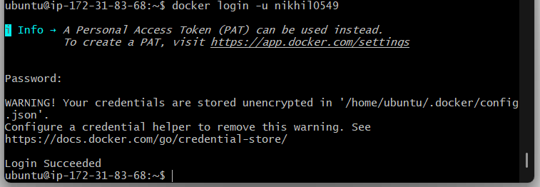

Step 3 — Check your current image
Run:
docker images
You should have:
REPOSITORY TAG
amazonlinux-nginx v1
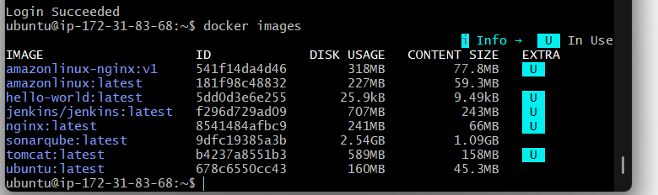

Step 4 — Tag the image
Docker Hub requires the image name to include your Docker Hub username.
Suppose your Docker Hub username is:
YOUR_USERNAME
Run:
docker tag amazonlinux-nginx:v1 YOUR_USERNAME/amazonlinux-nginx:v1
For example, if your username were nikhilreddy:
docker tag amazonlinux-nginx:v1 nikhilreddy/amazonlinux-nginx:v1

Step 5 — Verify the tag
Run:
docker images
You should now see both:
REPOSITORY TAG
amazonlinux-nginx v1
YOUR_USERNAME/amazonlinux-nginx v1
Both names point to the same image.
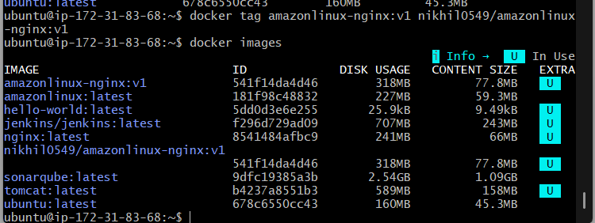

Step 6 — Push the image
Run:
docker push YOUR_USERNAME/amazonlinux-nginx:v1
For example:
docker push nikhilreddy/amazonlinux-nginx:v1
You'll see layers being uploaded:
The push refers to repository [...]
...
v1: digest: sha256:...
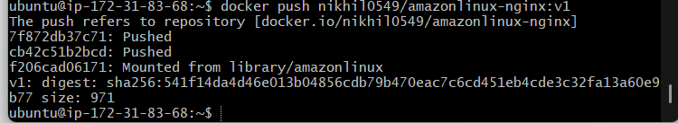

Step 7 — Verify on Docker Hub
Open your Docker Hub repository and verify that:
amazonlinux-nginx
contains:
v1
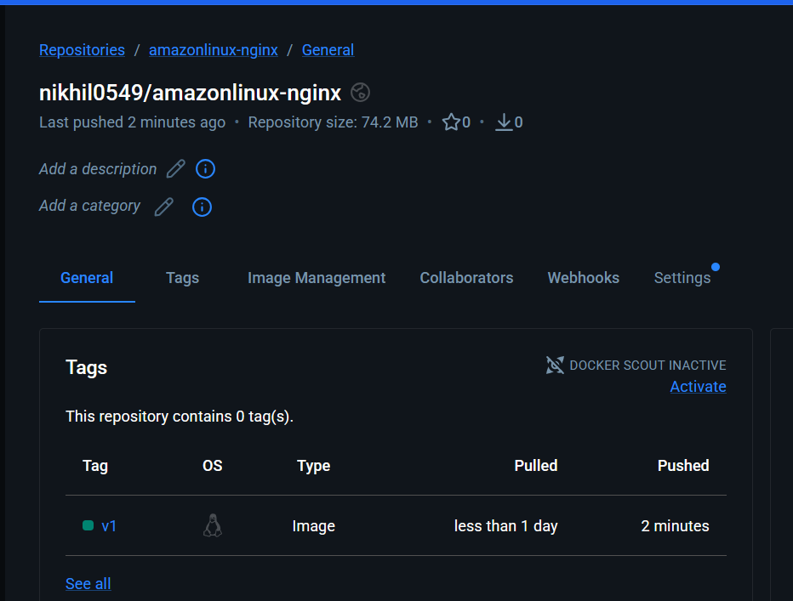

Step 8 — Test pulling the image
To demonstrate that the image is actually available from Docker Hub, you can remove the tagged local image:
docker rmi YOUR_USERNAME/amazonlinux-nginx:v1
Then pull it again:
docker pull YOUR_USERNAME/amazonlinux-nginx:v1
Verify:
docker images
You should see:
YOUR_USERNAME/amazonlinux-nginx v1
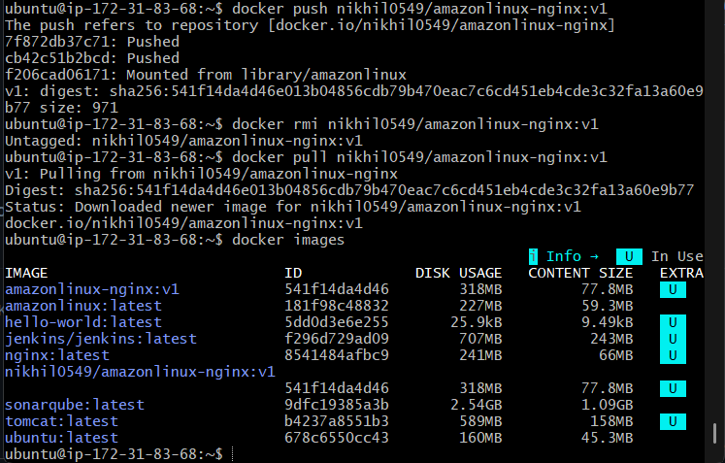

Task 6 — Push Docker Image to AWS ECR.
We will push the image that we created in Task 4:
amazonlinux-nginx:v1
to Amazon Elastic Container Registry (ECR).

Flow
EC2
|
| amazonlinux-nginx:v1
↓
AWS ECR Repository
|
↓
amazonlinux-nginx:v1

Step 1 — Make sure AWS CLI is installed
Run:
aws --version
You should get something like:
aws-cli/2.x.x ...

Step 2 — Check AWS credentials

First we need check our EC2 has an IAM role. If no IAM role attached then create.

Create an IAM role
Select:
Trusted entity type:
AWS service
For the use case, select:
EC2
Then click Next.

Give ECR permissions
AmazonEC2ContainerRegistryPowerUser
This provides the permissions needed to authenticate and push images to ECR.
Then after creating IAM role attach to ec2 instance.
Run:
aws sts get-caller-identity
You should get information similar to:
{
"UserId": "...",
"Account": "123456789012",
"Arn": "arn:aws:iam::123456789012:user/..."
}
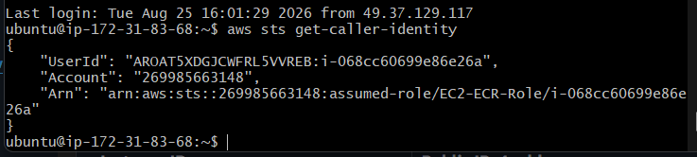

If this works
Our EC2 machine has permission to communicate with AWS.
For an EC2 instance, the preferred approach is to attach an IAM role with the required ECR permissions rather than storing AWS access keys on the server.

Step 3 — Create an ECR repository
You can create it from the AWS Console:
AWS Console → ECR → Repositories → Create repository
Use:
Repository name:
amazonlinux-nginx
Keep the other settings at their defaults for this practical.
Click:
Create repository
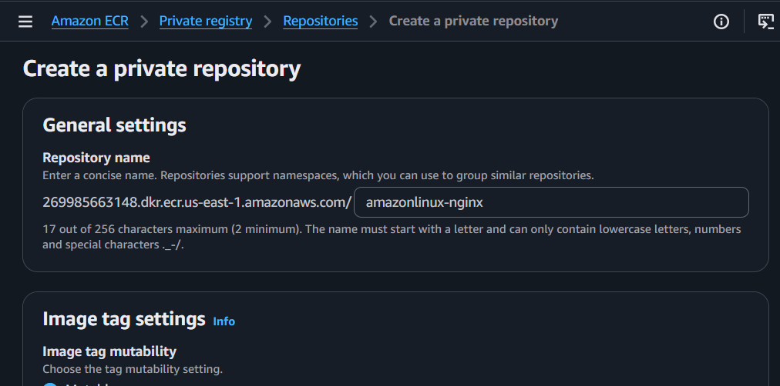
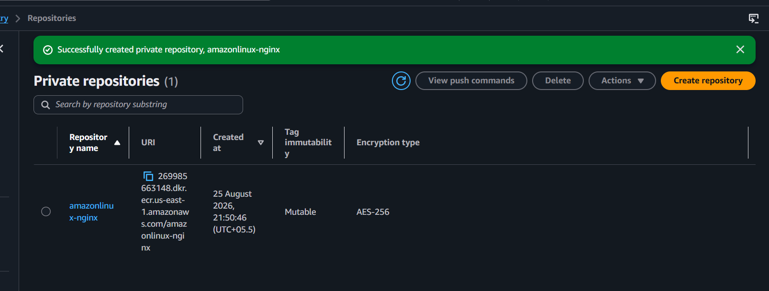

Step 4 — Verify the repository from EC2
Run:
aws ecr describe-repositories \
--repository-names amazonlinux-nginx \
--region us-east-1
You should get repository information.
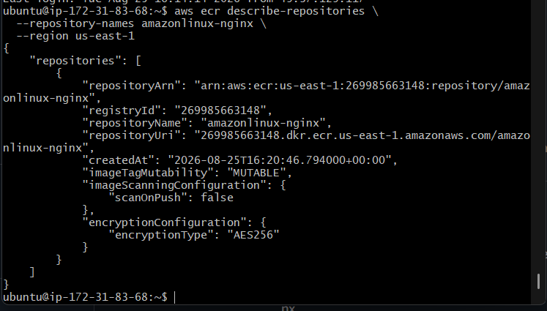

Step 5 — Get your AWS account ID
Run:
aws sts get-caller-identity --query Account --output text
Example:
123456789012
We'll call this:
ACCOUNT_ID
Your ECR image URL will be:
ACCOUNT_ID.dkr.ecr.us-east-1.amazonaws.com/amazonlinux-nginx
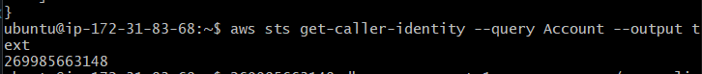

Step 6 — Login Docker to ECR
Run:
aws ecr get-login-password --region us-east-1 | \
docker login --username AWS --password-stdin ACCOUNT_ID.dkr.ecr.us-east-1.amazonaws.com
Replace:
ACCOUNT_ID
with our actual AWS account ID.
For example:
aws ecr get-login-password --region us-east-1 | \
docker login --username AWS --password-stdin 123456789012.dkr.ecr.us-east-1.amazonaws.com
You should see:
Login Succeeded
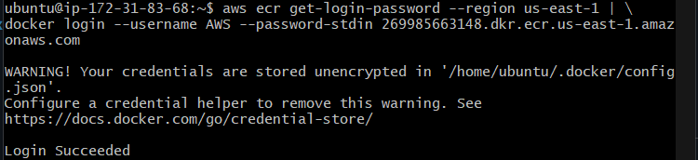

What is happening?
aws ecr get-login-password
↓
Generates temporary ECR authentication token
↓
docker login
↓
Docker is authenticated with ECR

Step 7 — Tag your image for ECR
our current image is:
amazonlinux-nginx:v1
Run:
docker tag amazonlinux-nginx:v1 \
ACCOUNT_ID.dkr.ecr.us-east-1.amazonaws.com/amazonlinux-nginx:v1
For example:
docker tag amazonlinux-nginx:v1 \
123456789012.dkr.ecr.us-east-1.amazonaws.com/amazonlinux-nginx:v1

Step 8 — Verify the image
Run:
docker images
You should now have something similar to:
REPOSITORY
amazonlinux-nginx
123456789012.dkr.ecr.us-east-1.amazonaws.com/amazonlinux-nginx
Both should have:
TAG
v1
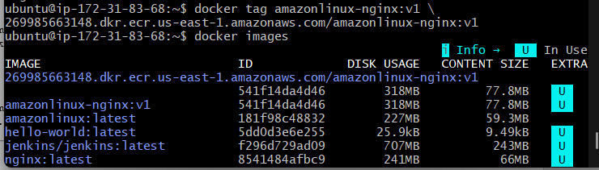

Step 9 — Push to ECR
Now run:
docker push \
ACCOUNT_ID.dkr.ecr.us-east-1.amazonaws.com/amazonlinux-nginx:v1
Example:
docker push \
123456789012.dkr.ecr.us-east-1.amazonaws.com/amazonlinux-nginx:v1
You'll see the Docker layers being pushed.
At the end, we should get something similar to:
v1: digest: sha256:xxxxxxxx...
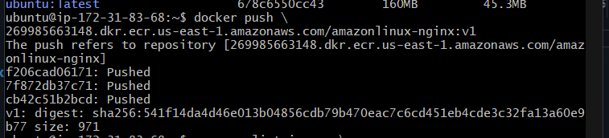

Step 10 — Verify from AWS CLI
Run:
aws ecr list-images \
--repository-name amazonlinux-nginx \
--region us-east-1
You should see:
imageTag: v1
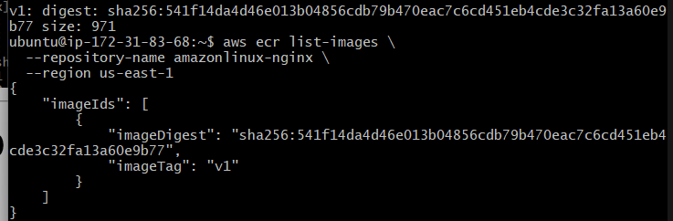
You can also verify it in:
AWS Console → ECR → Repositories → amazonlinux-nginx
You should see:
amazonlinux-nginx
|
└── v1
